HORIZONTAL STABILIZER AND ELEVATOR

CONSTRUCTION OF THE HORIZONTALSTABILIZER

Inspect the pre-molded top and bottom horizontal tail skins. Note that each skin consists of a horizontal stabilizer skin and elevator skin which have been factory molded in one piece. Identify from the factory labels the top stabilizer (K105T) and top elevator (K106T). Identify the bottom stabilizer (K105B) and bottom elevator (K106B). The top surface is flat spanwise, the bottom surface has a subtle crown at the center line. Using a felt pen label “top” and “bottom” on both the inside and outside of the stabilizer and elevator tops and bottoms. Also place arrows indicating forward (direction of flight) on these parts to avoid confusion when directions call out “forward face” of some member. When labeling the inside surfaces lift the peel ply as required.
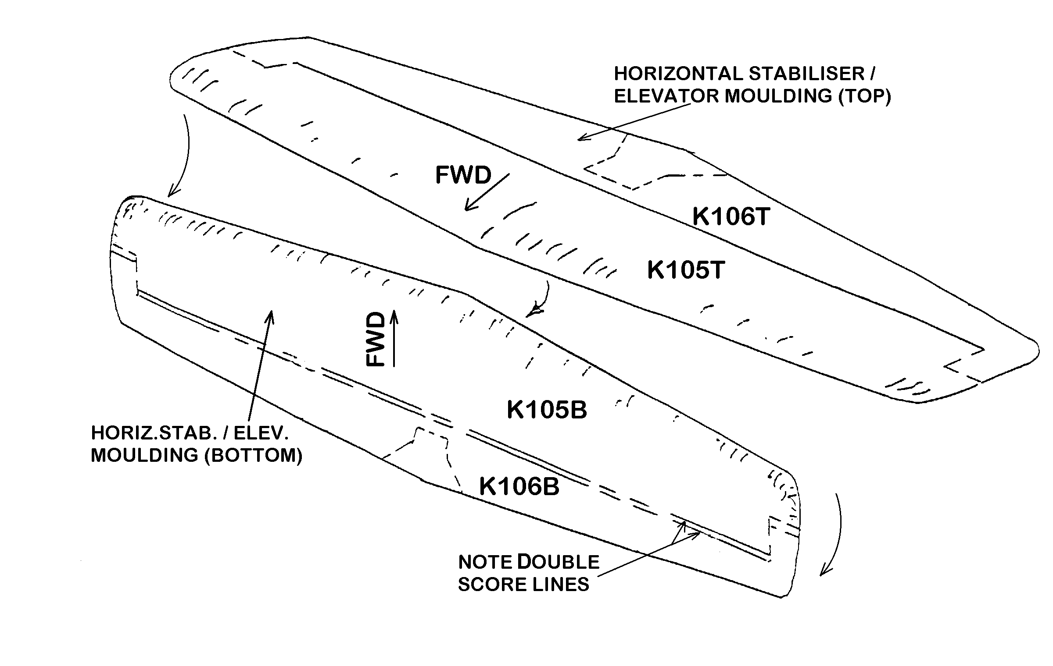
Find the scribe lines that will part the stabilizer and elevator on the outside of each molded piece. These lines run straight across and then around the elevator balance. Note that on the bottom piece only that there are two straight 81½ inch scribe lines rather than one. The ¾ inch piece in the middle gets removed to permit down elevator clearance when finished. Run a soft pencil along the lines for visibility.

Cut along each line very carefully to cleanly separate the elevator and stabilizer skins. An electric saber saw with fine tooth blade or a handsaw may be used. (Razor back saws and hack saw blades in special holders work well.) When the cuts are complete sand the edges of the stabilizer and elevator skins with a long block and 80 or 100 grit paper. Place the elevator top and bottom aside. Discard the ¾ x 82-inch piece.

Remove all the peel ply from the two stabilizer pieces. Measure and mark the center line, B.L. 4.5 Left and Right, B.L. 20 Left and Right, and B.L. 40.75 Left and Right on both the top and bottom pieces. A large square will be handy here. Measure 1½ inches forward of the scribe line and lay out a line parallel to the scribe line for spar aft face location.

After marking the locations for the spar and ribs is a good time to prepare the areas of the skin for bonding. Take a piece of 80 grit sandpaper and roughen the areas around the spar and ribs on both the top and bottom. Light sanding is all that is needed to give resin a good surface for adhesion. Sand the area that lies within 2 inches of each side of the ribs; sand the area from two inches forward of the spar back to the rear edge (hinge line) of the stabilizer.
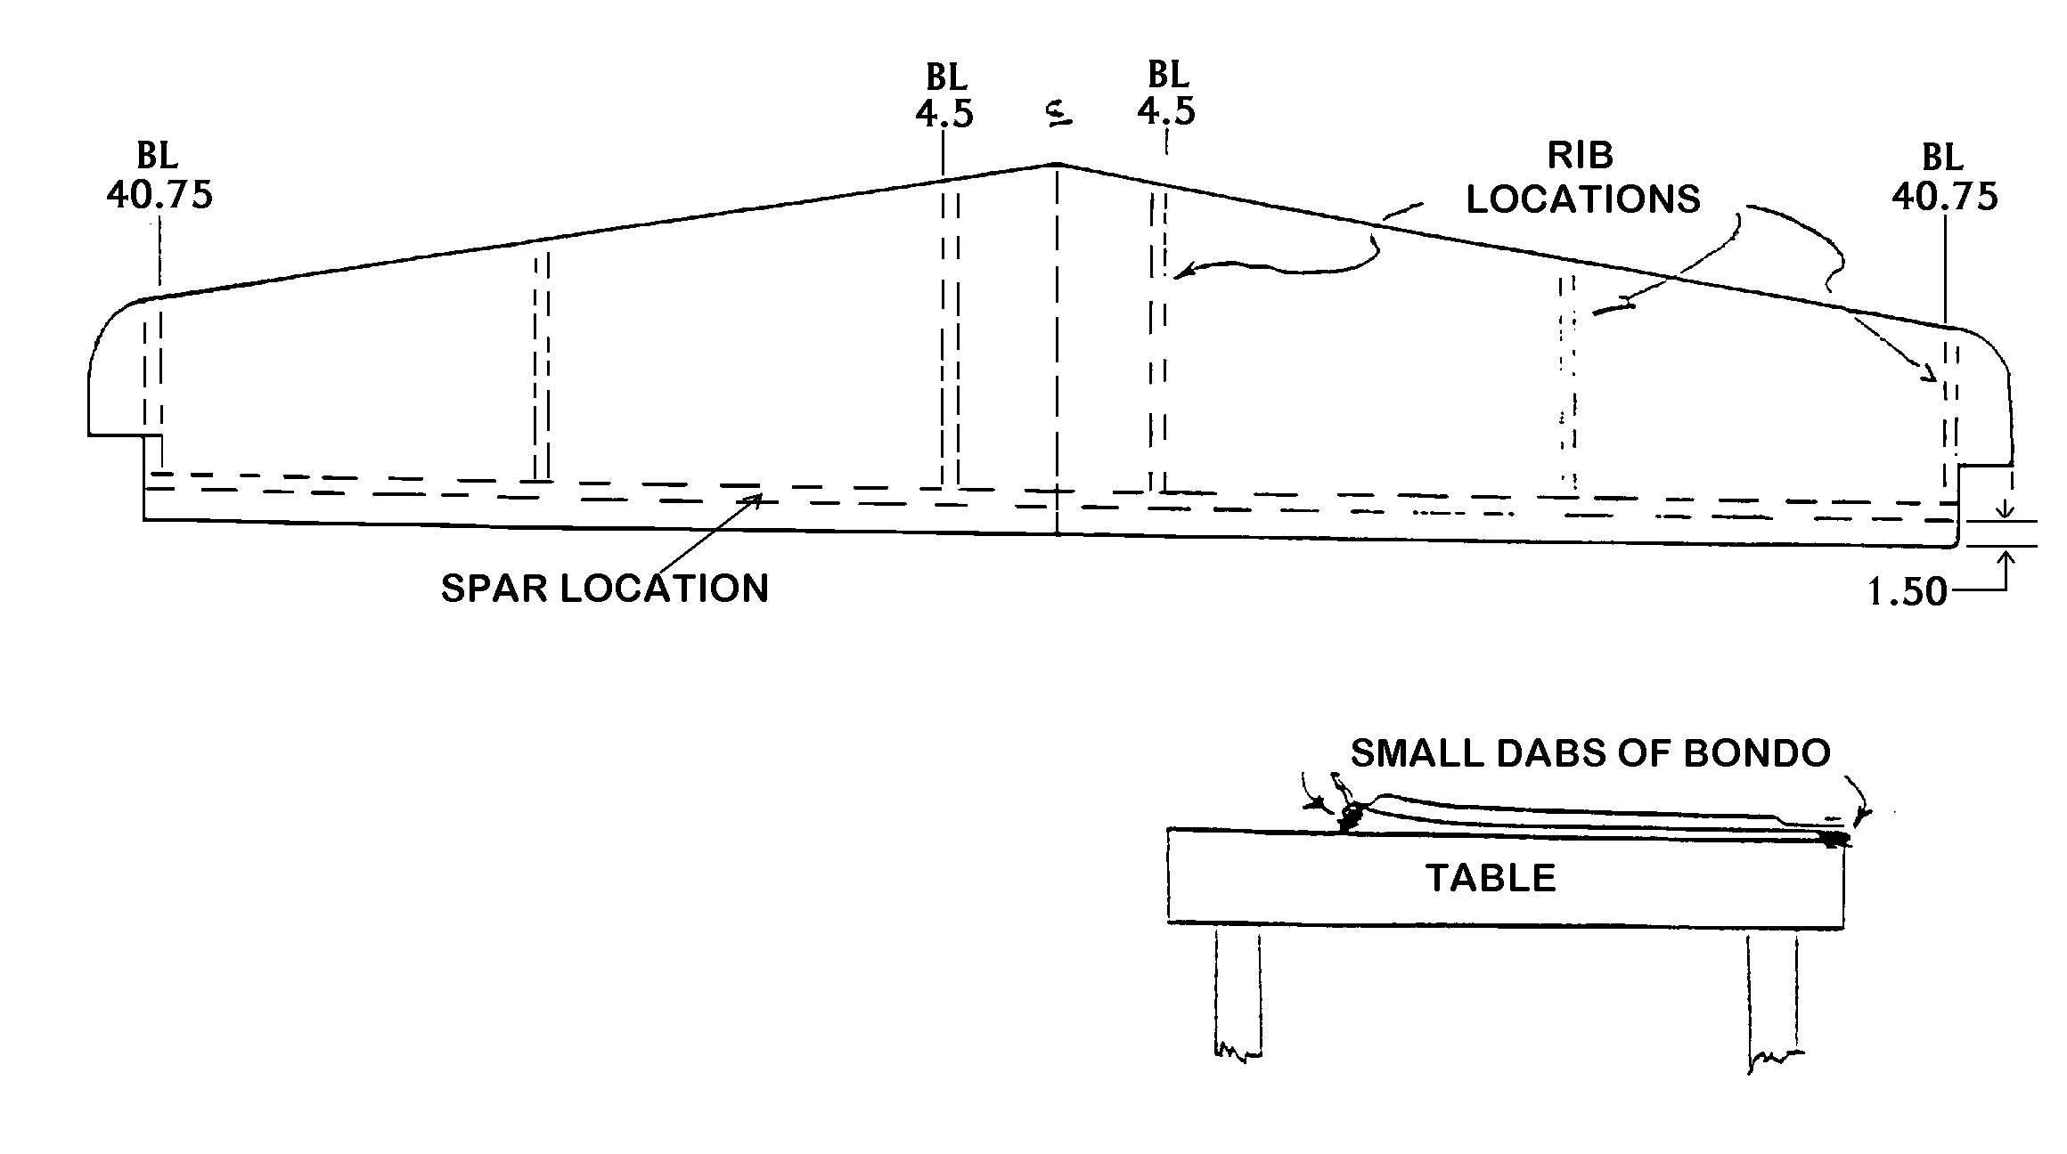
Place the top stabilizer skin upside down on a straight work board or table. Using a couple of clamps or weights to temporarily hold the skin down, place 4 or 5 small dabs of bondo along trailing edge as shown. In a similar manner the leading edge should also be temporarily adhered to the bench at 4 or 5 places using small dabs of bondo and scraps of wood, if necessary. Be sure that the skin is held straight and true. When the bondo has cured remove the clamps or weights.

Using a soft pencil or fine felt point pen lay out the stabilizer spar on ¼ inch foam using the dimensions shown below. At the same time lay out two B.L. 4.5 ribs, two B.L. 20 ribs and two B.L. 40.75 ribs using the templates supplied. Use a knife to cutout the 7 parts. Make the ribs at least ¼ inch oversize all the way around. Check fit and trim these parts to fit the upper skin when in their proper location. Leave the ribs slightly oversize on the edge that will later be fitted to the lower skin.
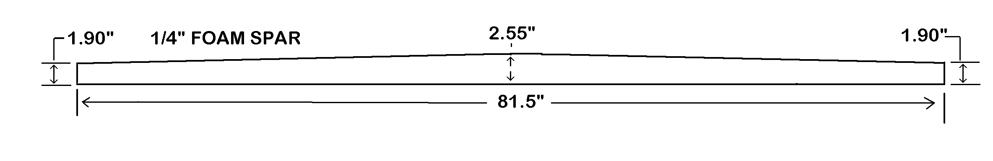
This is a good time to cut most of the glass cloth (BID) required to build the stabilizer and the elevator. Cutting most of the glass at one tome helps save time late and keeps the cutting area cleanly.

Lay the glass out on your cutting table. (No resin is ever used around this table. Nothing is fabricated on it.) All the pieces will be cut at 45-degrees to the selvage edge and made as long as the 38-inch cloth will permit (approx. 53 inches). Mark about 3 or 4 lines at one time depending on the space available on the cutting board. Use a felt pen and long straight edge. Cut these pieces and then mark some more. This is the first time that you have handled 45-degree bias-cut glass. Note that its width becomes wider or narrower if pulled out of shape. Handle it carefully.

6 pcs - 5-inch wide approx. 53 long for 4 inch PreLam
8 pcs - 7-inch wide approx. 53 long for 7 inch PreLam
4 pcs - 4-inch wide approx. 53 long for 3 inch PreLam
4 pcs - 3½-inch wide approx. 53 long for 2½ PreLam
2 pes – 4-inch wide approx. 53 long for hand layups
2 pcs - 3-inch wide approx. 53 long for hand layups

Note that the strips intended for PreLams have been cut 1 inch oversize. Pile the strips into organized labeled piles.

Use 5 minute epoxy in 5 or 6 dabs to attach the foam spar with its aft face located on the parallel reference line located 1½ inches forward of the rear edge (hinge line). The spar forward face will then be 1¾ inches ahead of the edge. Note that the spar’s straight edge (as opposed to the edge with dihedral) goes down onto the skin. The epoxy is intended only to temporarily locate and support the spar until glass and resin are applied and cured. When the dabs of 5-minute epoxy cure mix a small cup of medium-wet micro and lay a small fillet about ¼ inch wide along the corner formed by the forward edge and the skin. Avoid getting the micro on any area beyond the actual fillet; wipe excess off where this occurs.

The micro fillet will radius a three ply PreLam 4 x 85 laid as shown in the drawing. When preparing the 4 inch PreLam lay out 5 inch cloth. Because the lengths of BID are shorter than 85 inches it will be necessary to splice when preparing the PreLam. This is done simply by overlapping pieces by about 3 inches. Vary the position of the splice from layer to layer.

Prior to positioning the PreLam you must prepare the forward surface of the foam spar by filling the pores in the face with wet micro slurry. Use a small squeegee to apply the slurry. The 3 ply PreLam may now be laid against the forward face of the spar and down onto the surface of the skin. Approximately 1 inch should overlap onto the skin and the excess will hang over the top of the spar.
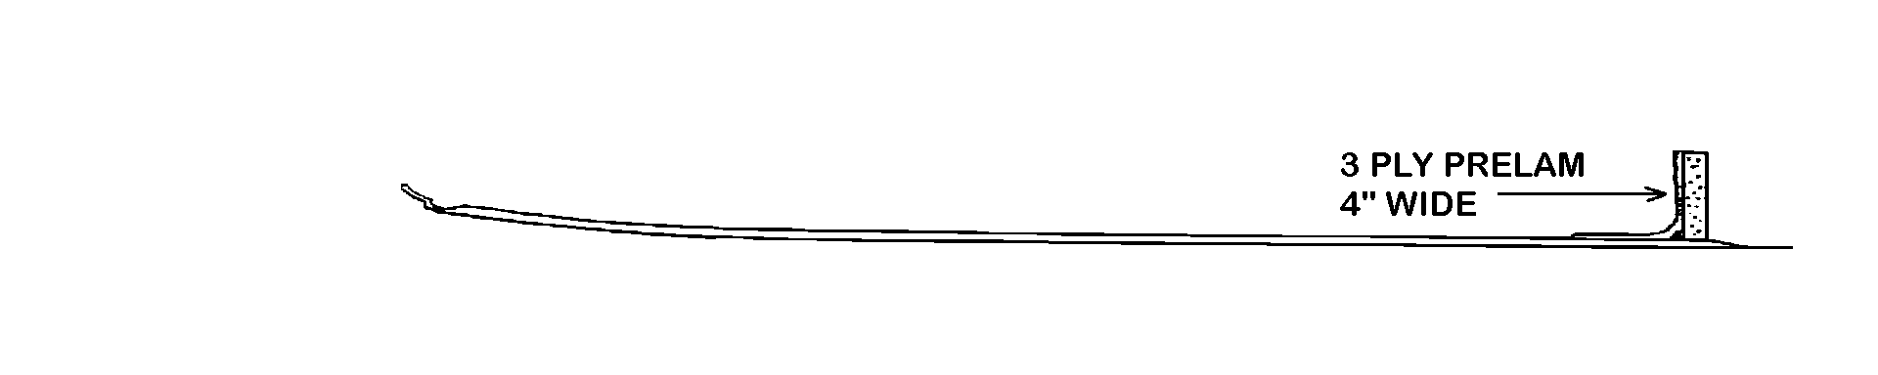
While that resin is wet use 4 or 5 dabs of 5-minute epoxy to secure each of the six ribs in place to the skin. (Note that the out-board ribs should be exactly flush with the counter balance cut-outs. Some lightweight objects will help hold the ribs while the 5-minute epoxy kicks off.
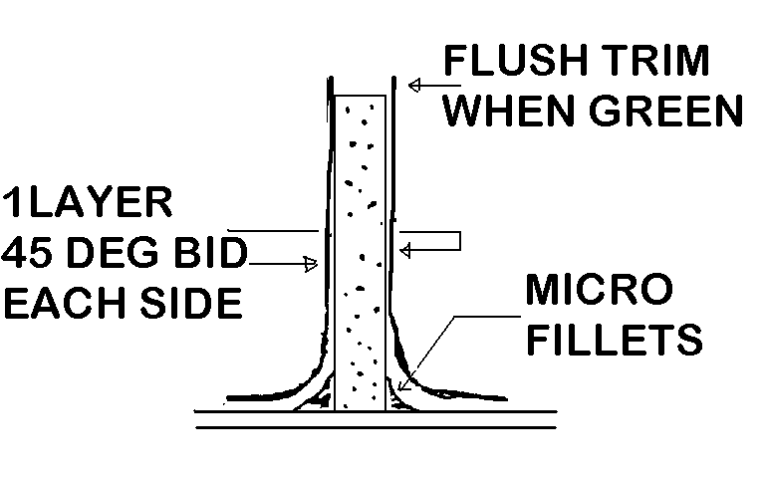
As with the spar corner, apply some micro to form small fillets at the bottom corners of the ribs. Then cut lengths from the 4 inch glass cloth strips and resin one layer of this cloth to each side of the six ribs. Once again the cloth should overlap the skin by about an inch. Make a flox joint as shown where the outboard sides of the outboard ribs interface with the skin. (Refer to Procedures Section for more on flox and micro/flox joints.) See drawing on next page.

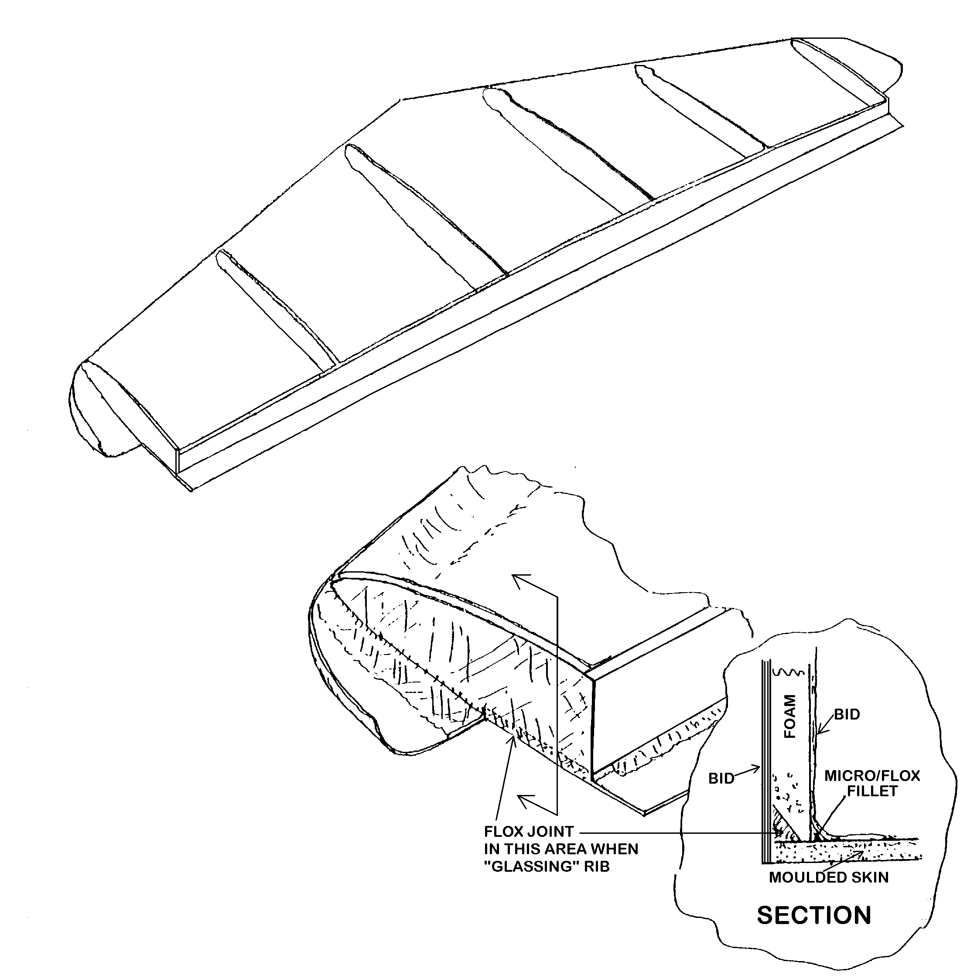

Step back and eye everything to assure you have not goofed. If everything looks okay let the resin cure to a “green” condition where it is fairly rigid but can still be trimmed with a knife. This may mean setting the alarm clock for 3 A.M. in the morning. (Assure yourself and sleeping companion that this won’t happen too often.) Trim the excess glass protruding over the top of the spar and ribs. Use a new razor or razor knife blade only as long as it cuts easily and cleanly. Replace it often. A wooden block may help as backing during knife trim operations. Regardless of the technique it is important that you end up with a neatly trimmed assembly which is ready for the lower skin.

After the resin has cured thoroughly (usually 12 to 24 hours depending on temperature) the sub-assembly can be prepared for adding the bottom skin. First lay the bottom skin in place on the stabilizer sub-assembly. The skin should rest properly on the top surfaces of the ribs and spar. Check for any interference that will prevent the bottom skin from mating (i.e. check that the leading edge and tips are just contacting). Use a sanding block to correct interference at the tops of ribs and spar.

Cut a bevel or “V” slot in the foam spar where shown. A flox joint here will tie the glass spar web to the skin.
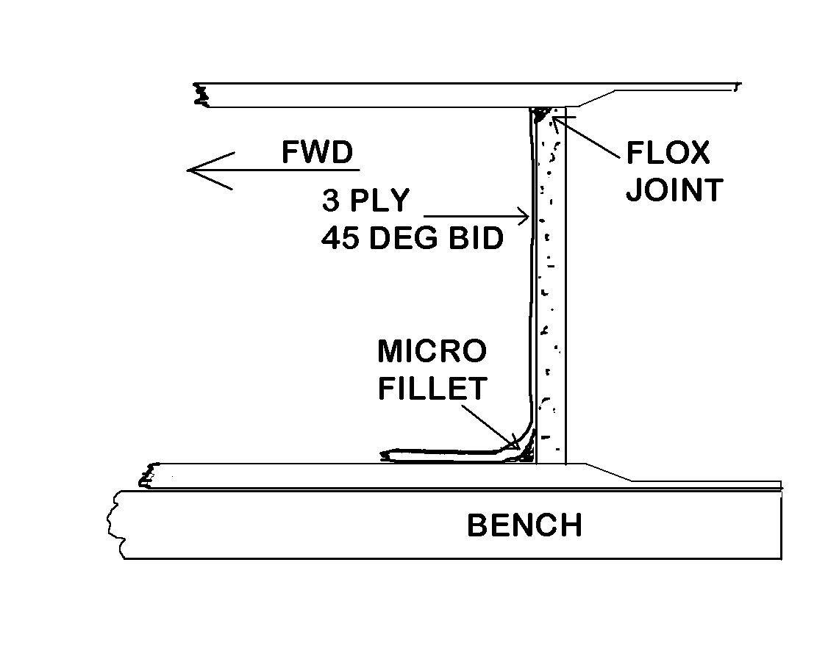
Also remove foam to form a flox slot at the top of each rib as shown. Fill the slot in the spar with flox. Pile the joint high with excess flox. Fill rib slots with flox; pile about ¼ inch of excess above the ribs. Carefully place the bottom skin in place as accurately as possible to avoid sliding. Use some strips of masking tape to hold the surfaces together and edges straight while the flox cures overnight.
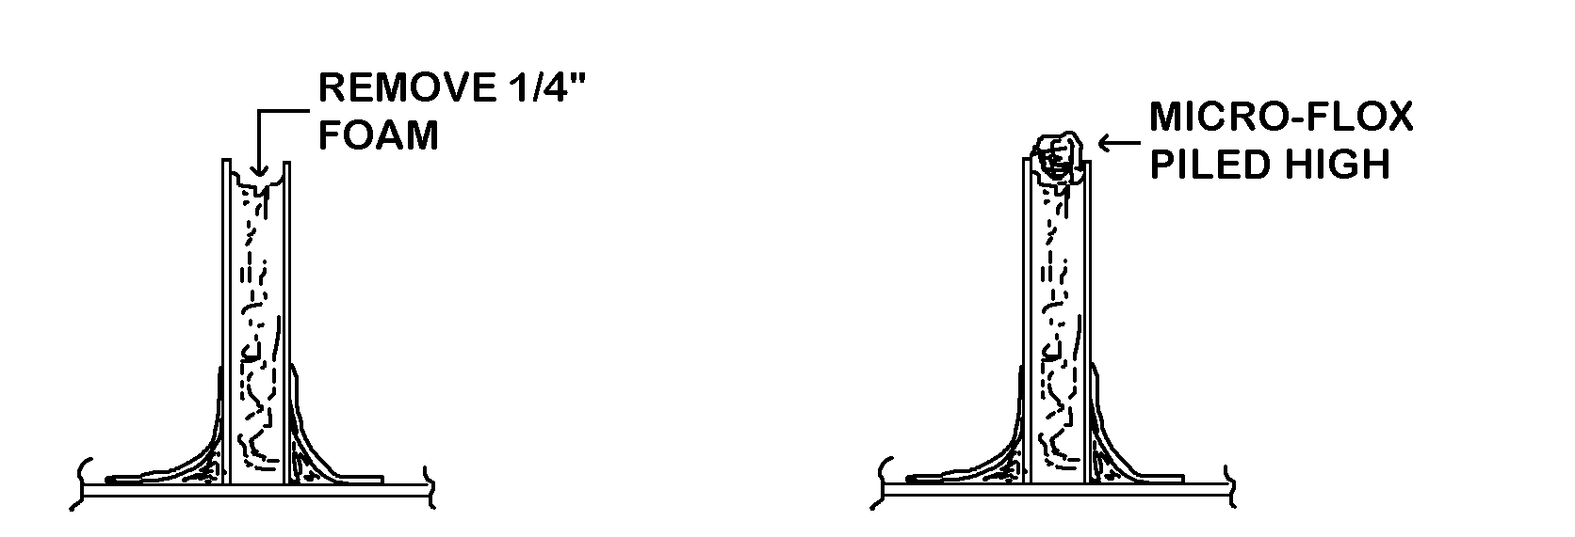
Prepare a 4-ply PreLam 7 inches wide for the open channel formed by the upper skin, lower skin, and spar. Run some micro/flox fillets along the corners and then squeegee the PreLam into place. Trim when ready.

Make two 4-ply PreLams 3 x 10. Apply these at the outboard aileron hinge locations, i.e. at left and right BL29.5 to 37.5. Note that the 10-inch cloth reinforcement is a little longer than the hinge, it will run from about 28.5 to 38.5. Make one 4-ply PreLams 3 x 26. Apply it as hinge reinforcement from BL13L to BL13R.

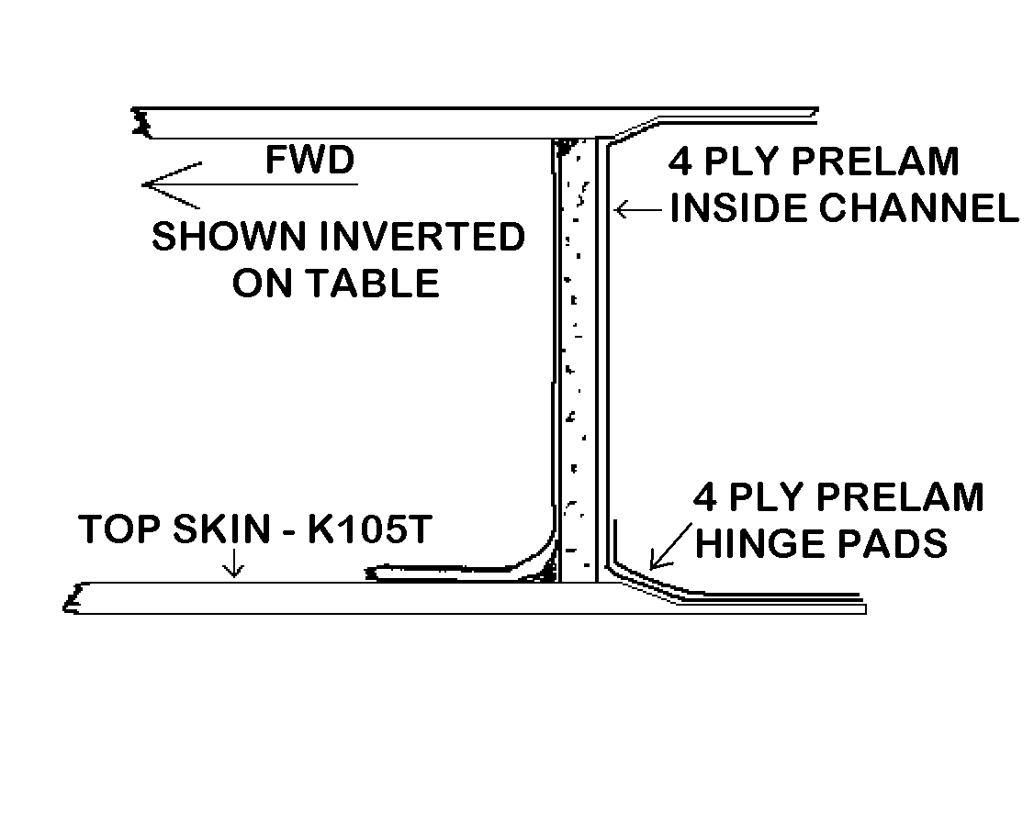
A “green” trim will be required to remove the excess BID along the 2 trailing edges of the channel. When completely cured block sand the edges to assure they are absolutely straight from tip to tip. This should help later when aligning hinges.

Carefully break the bondo dabs that secure the stabilizer to the bench and remove it for the next operation. Sand the leading edge and tip recess with 80 grit sandpaper for good “bite”. Make up two 2-ply PreLams 2½ x 55. Start one PreLam at the left tip of the recess and terminate it about 2 inches past center. Now take the other PreLam and apply it to the right leading edge recess with overlap at the center.
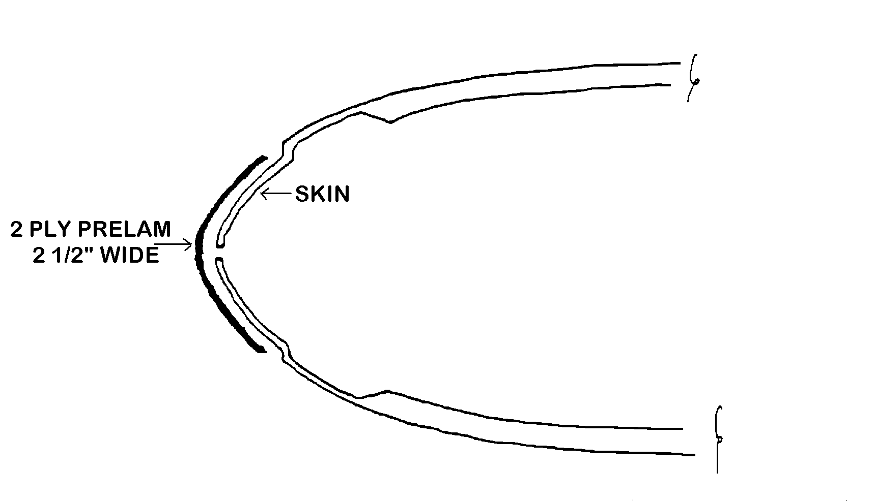
Mark and cut four 3/32-inch hinge cutouts in the upper aft edge using a saber saw. Block sand the slots.
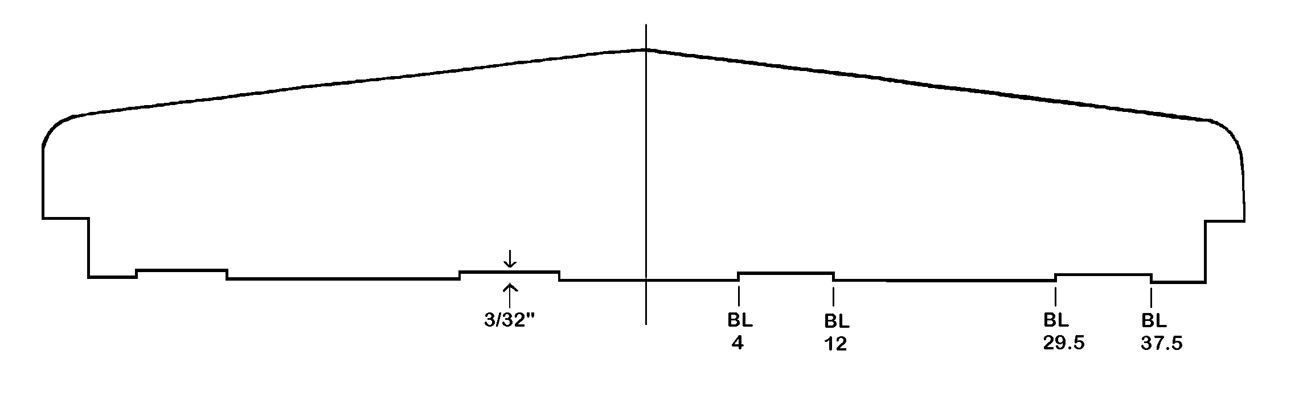
You will notice that the tip cavities are open. These should be faced with a piece of ¼ foam held in place with some 5-minute epoxy. After these are in place prepare the corners for flox joints, add the flox, and face the foam with one layer of BID.

The stabilizer is complete.

CONSTRUCTION OF THE ELEVATOR

Construction of the elevator is performed somewhat like the stabilizer except it is best to prepare selected metal parts, foam and phenolic spar pieces, and foam ribs prior to starting other efforts.

Cut the ribs out of ¼ foam using the templates supplied. Make them slightly oversize. Mark ¼ foam and ¼ phenolic to the spar dimensions shown below. (A band saw or saber saw is best for the phenolic). Cut the pieces out but do not butt glue them together yet. Note that the spar is crowned so each piece should be marked up so the spar can be assembled correctly. The flat edge of the spar is the top edge.
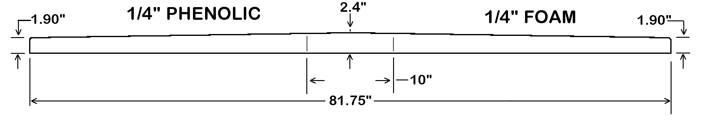
You may now prepare the top skin K106T and the bottom skin K106B for the inverted building process. The elevator trim tab cut lines and the center cutout area lines are already scribed into the top skin. Make them more visible with a soft pencil. Saw out only the center area of the top skin at this time. (Do not cut the trim tab from the top skin. Do not cut the bottom skin at all.) Make the cuts with a saber saw or hand saw as carefully as possible. Clean up the cuts with a sanding block.
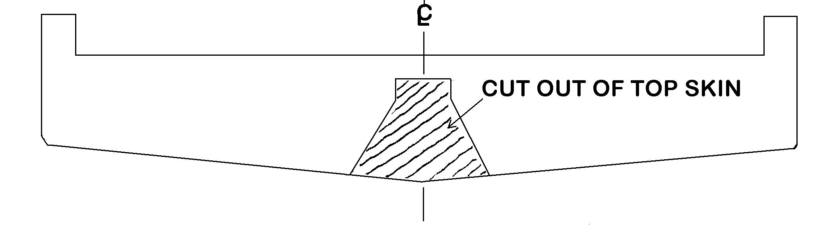
Handle the top skin with extreme care once the center cutout material is removed. It will be very easy to inadvertently damage the remaining glass in the center area.

Trace the outline of the top skin center cutout onto the bottom skin with felt pen. Mark the exact center lines (BL0) on both skins. Mark the inside surfaces of both the top and bottom skins to show approximately where the ribs will be located. Note that the inboard ribs are inset ½ inch from the edge of the center area which has been removed from the top skin. The outboard ribs fit flush with the counterbalance cutout. Mark the exact spar location on the top skin. Its forward face should be 1¼ inch from the trimmed edge (hinge line). Also mark where the hinges will go (BL4 to 12 and BL29.5 to 37.5).
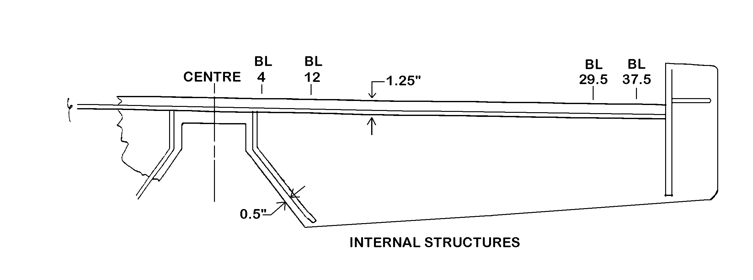
Prepare the top and bottom skins for subsequent layups by sandpapering the resin contact areas. These areas will be along the trailing edge bonding surface, within about 2 inches of both sides of the ribs, and from the hinge line aft about 3 inches. Also sand the entire inside area of the both skins in the right and left counterbalance areas. Mass balance weights will be bonded into these areas later.

Place the top skin inverted on the building table. Have the hinge and balances towards the builder. Hold it in position with a few dabs of bondo. We are now ready for the spar.

Block sand all sides of the phenolic. Then bond the three spar pieces together on a flat surface using 5-minute epoxy and masking tape. The spar can now be moved to the skin. Perform a fit check with the spar and ribs put temporarily in place. Trim the spar to exact length. Note that the spar should not sit exactly vertical to the skin but should be slanted slightly (about 1/8-inch tilt) towards the trailing edge.

Micro slurry the aft face of the spar using a squeegee. Run a ¼ inch fillet of micro down the corner where the spar ties to the skin. Prepare a 2-ply PreLam 4 x 85. Place it on the aft face of the spar. Be sure that at least an inch of the PreLam lays on the skin. Some should extend slightly above the to p of the spar. Remove the plastic support sheet from the PreLam after using the plastic as a surface to squeegee it onto the spar.
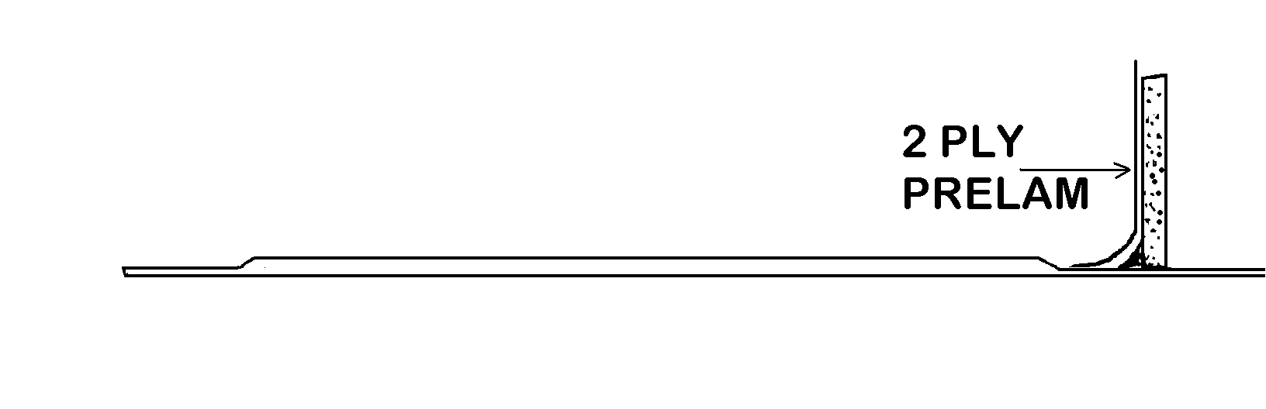
While the spar glass resin is still wet put the ribs into place on the top skin with 5-minute epoxy. Use some small weights to temporarily hold the ribs to the skin until the 5-minute epoxy cures. Run a ¼ inch micro fillet in each corner of the outboard ribs only.

Apply two plies of BID with resin to both sides of the outboard ribs. Note that a micro-flox joint is required at each counterbalance edge where shown on the drawing. Do not glass the inboard ribs at this time.
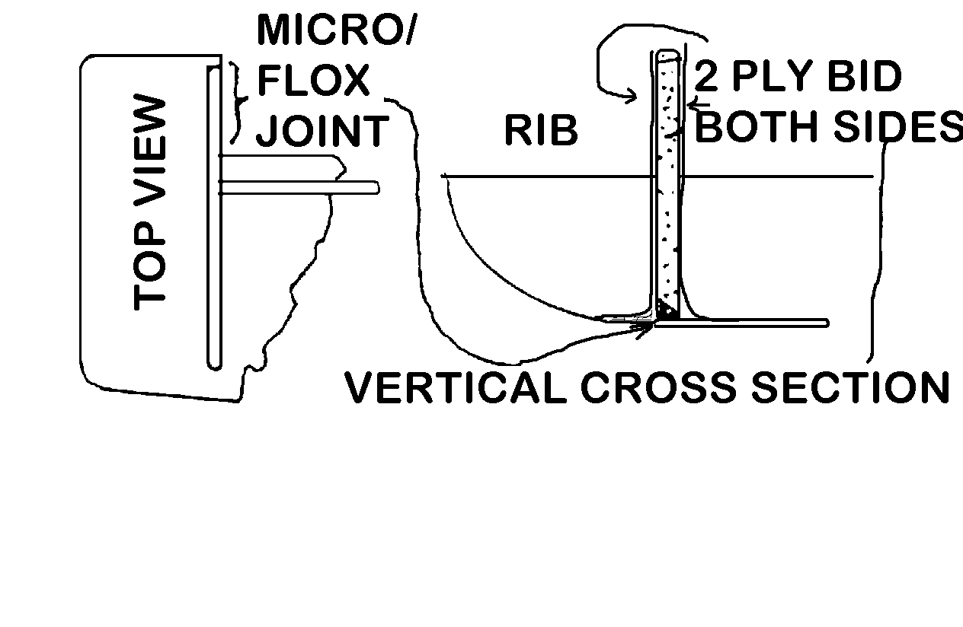
Before taking a break be sure to inspect the structure and all the glassed areas. The glass laminates should overhang the upper edges of the ribs and be in good contact with the rib sides, skin, and spar. If everything looks okay you can relax until its time for a green trim of the excess cloth hanging over the spar and ribs.

The next building steps involve installation of the elevator horn, KS-lA. Clamp the horn in place. (See drawing on next page.) Use a cardboard spacer about .060 thick under the rolled lip of the horn to space it up for two PreLams to be applied later. Drill eight 3/16-inch holes through the spar using the holes in the horn as pilots.

Temporarily bolt the horn to the spar for a quick fit check. Lay the bottom skin approximately in place. Mark the portion of the skin that interferes with the horn and relieve it with a saber saw. The skin should then go into position.

Remove the bottom skin and the four bolts holding the horn and remove it. Proceed so as to secure eight K1000-3 anchor nuts to the forward face of the spar. These are required so that the elevators and horn can be disassembled and reassembled for installation on the aircraft.
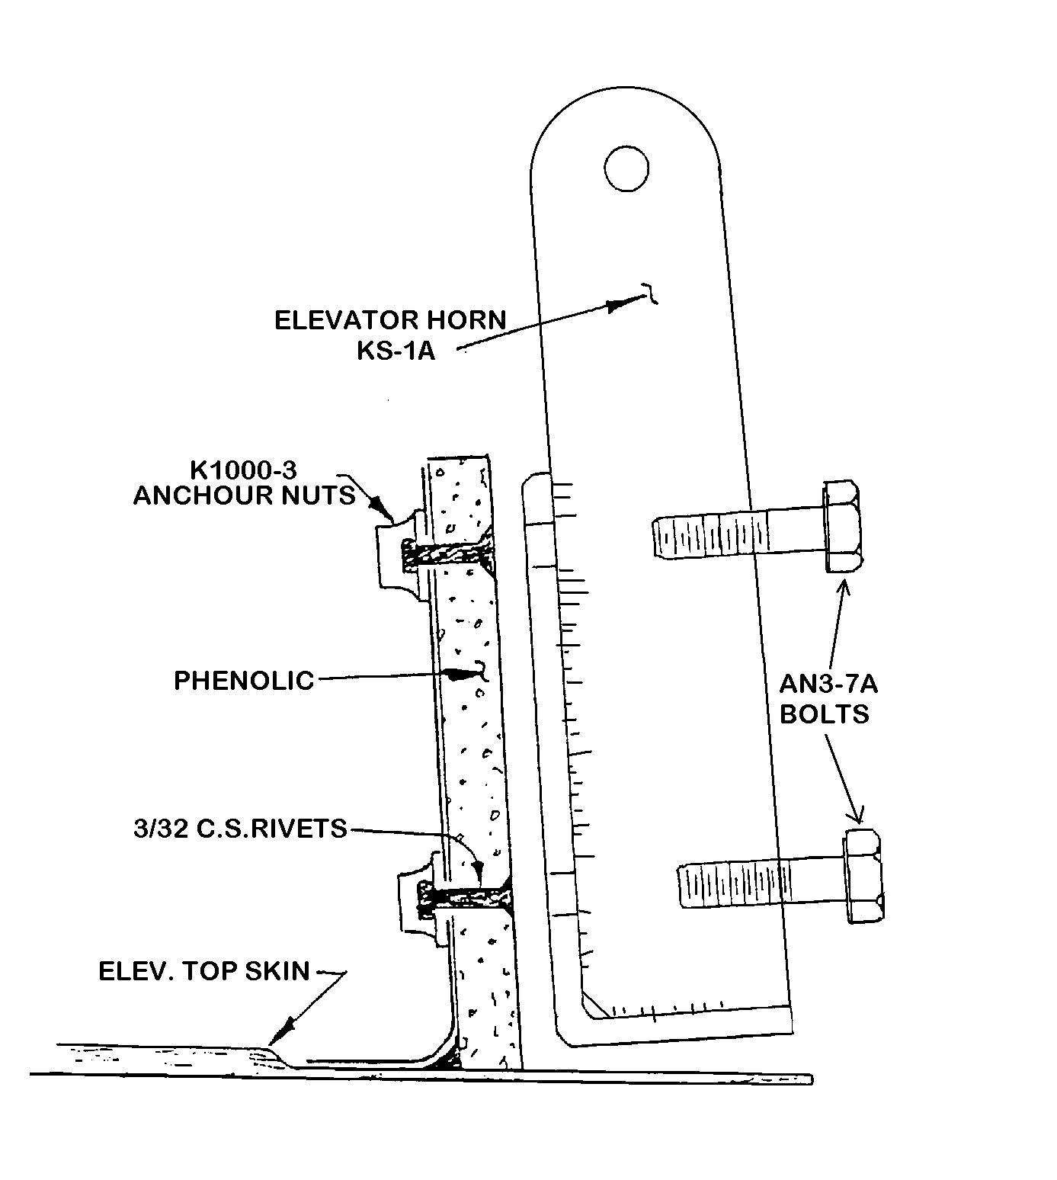
These nuts must be properly captured in position because once the bottom skin is in place they cannot be reached. Drill sixteen 3/32 holes through the spar from its forward face using an anchor nut as a drill guide. Countersink the holes slightly on the forward face so that countersunk type rivets can be used to secure the anchor nuts to the aft surface of the spar. Rivet the nuts in place using a rivet squeezer or small hammer to form the rivet heads.
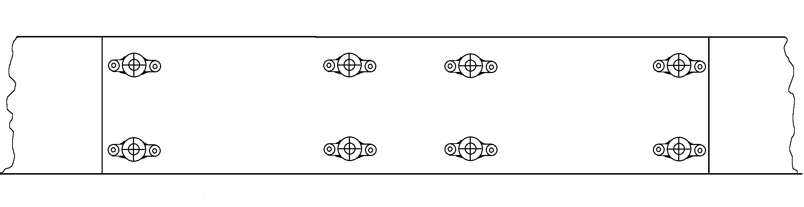
Bolt the horn into place to assure that the anchor nuts are secure and that everything is ready for closing the elevator assembly by adding the bottom skin. Remove the bolts and horn. Fill the anchor nuts and the holes through the phenolic with child’s modeling clay. This will protect them from becoming fouled with epoxy.

Take a piece of scrap ¼ inch foam and make bulkheads for the counterbalance weight areas. These should be securely installed as shown in the counterbalance areas with 5-minute epoxy. Their only purpose will be to temporarily trap small shot when the balancing step is carried out later. They need not be glassed. Note that at this time the forward end of the counterbalances is open.
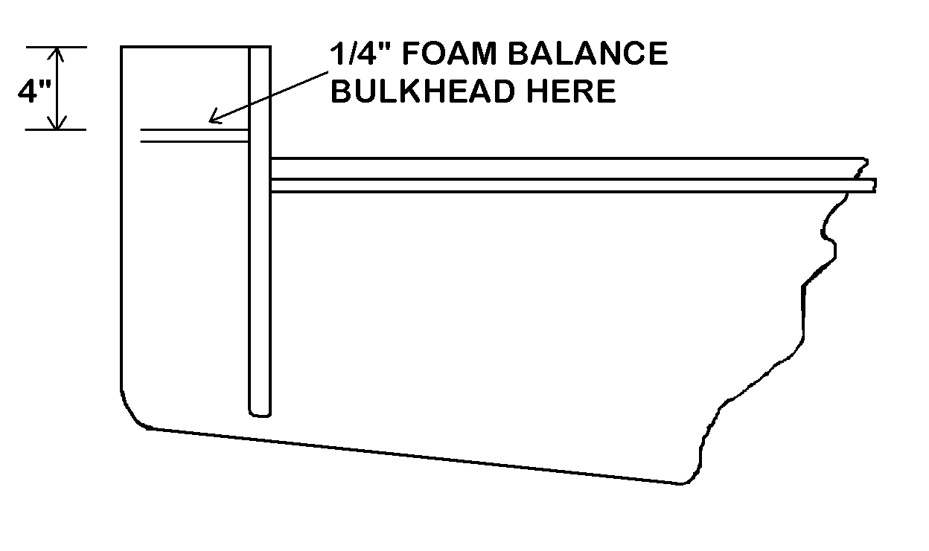
Before closing the assembly a pair of hinge spars must be installed for the single trim tab which will be on the starboard or right side of the aircraft. Mark its position as shown looking down on the inverted assembly.
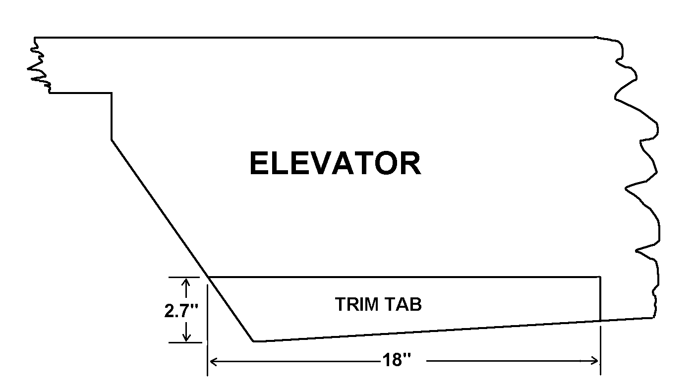
Now mark the positions of the hinge spars on the top skin. Cut two pieces of ¼ foam, 7/8 inch high and 18 inches long. Taper their edges with a sanding block so they sit on the skins properly. Using 5-minute epoxy bond them onto the top skin in the positions shown. Note that they are spaced to allow room for the hinges.
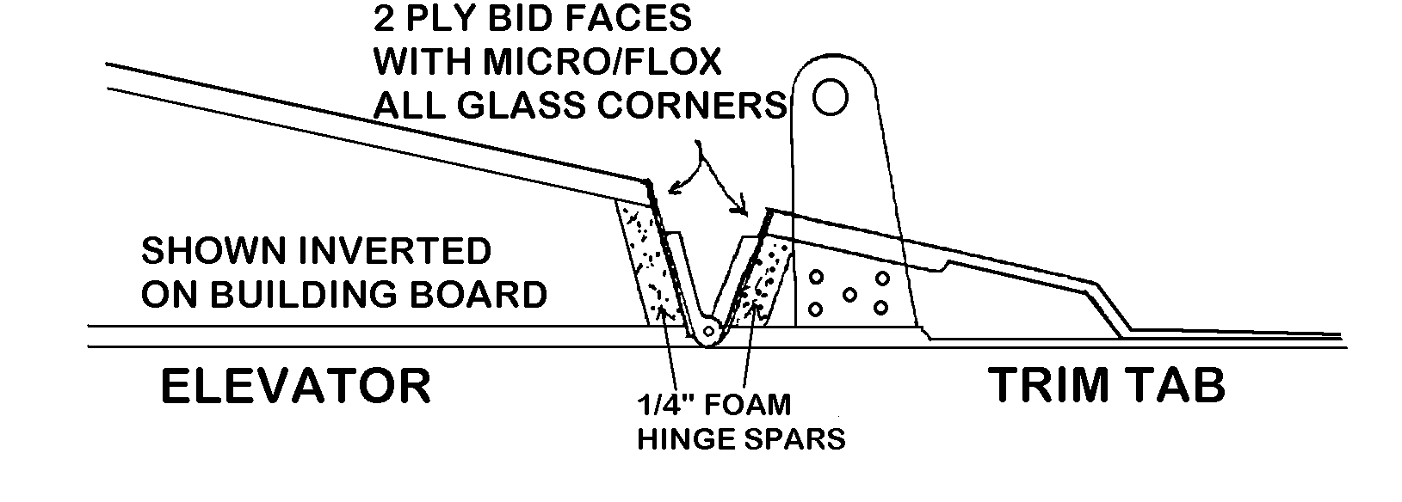
NOTE: SEE PAGE 20 CONCERNING OPTIONAL ELECTRICAL TRIM

Make a trim tab horn of .063 aluminum as shown below. Lay extra foam into the trim tab area where the horn will be installed. The foam will make a pocket for flox that will hold the horn when it is installed after the assembly is closed.
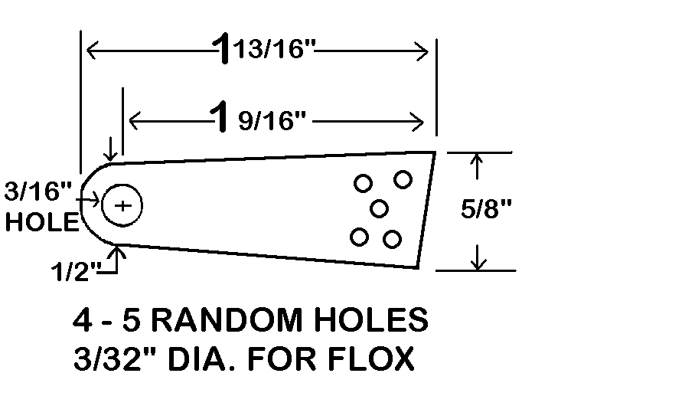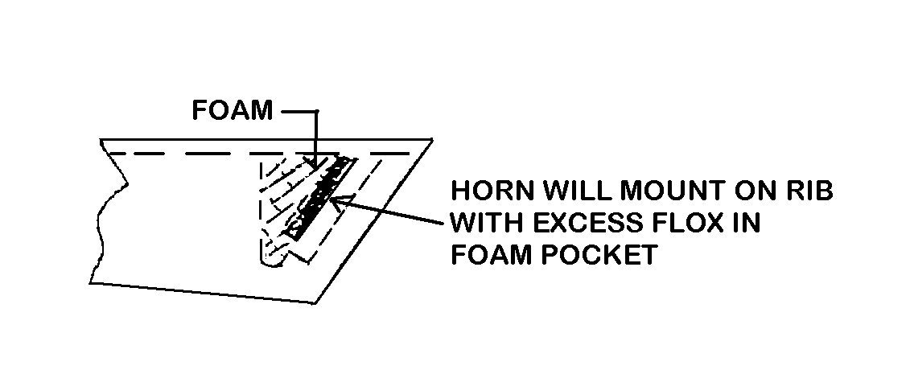
The bottom skin may now be added. Take plenty of time to make sure that the bottom fits properly on top of the spar, ribs, and trim tab spars. No doubt some areas will have to be relieved with a sanding block to permit a good flush fit of the skin at all the joining edges.

Prepare the elevator spar and the ribs for micro-flox joints. Remove about ¼ inch of foam along the top edges of the ribs; relieve the foam within 1/8 inch of the spar glass. Mix up some 50/50 micro-flox and fill the resultant channels in the spar and ribs. Pile the micro-flox an extra ¼ inch above the glass edges. Put some along the top of the two trim tab spars. Apply a good coat of resin along the trailing edge bonding surfaces. Place the bottom skin in position avoiding sliding. Tape the edges and apply weights to hold everything in position until the resin cures.

Break the bondo dabs that hold the elevator to the table and remove it for ease in carrying out the remaining steps. Make a 2-ply PreLam 5 x 85 to go down the spar face and around the “U” channel covering all surfaces. Add a 4-ply inboard hinge reinforcement pad as shown from BL13R to BL13L. (This pad is shaped the way it is to make a flat surface to mount the elevator horn on the spar.) Add 4-ply pads 3 x 10 at the outboard hinge positions. Trim the glass when it has cured to a “green” condition. Be sure to remove glass and clean up the eight bolt holes which were covered by the PreLams.
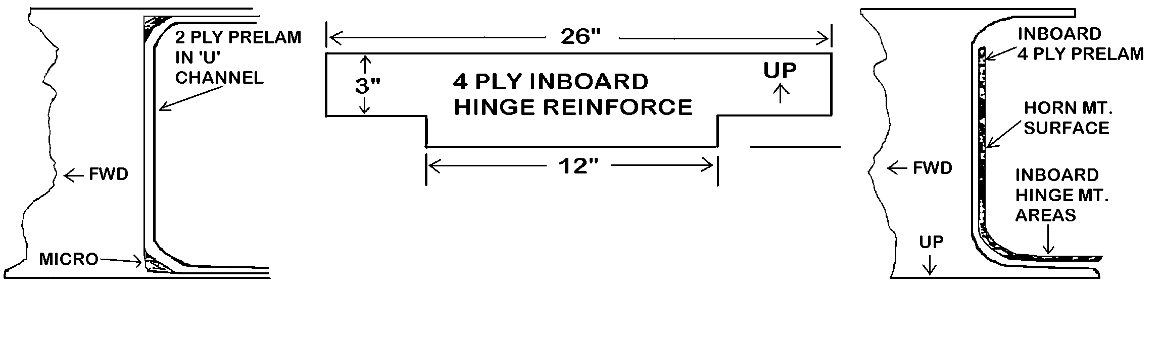
The next step is to remove the center area of the bottom skin using a fine tooth saw. Do this carefully so as not to loosen the skin where it bonds to the inboard ribs. Clean up the center area and lay in two plies of BID as an end closure. The glass channels formed will act as structural ribs.
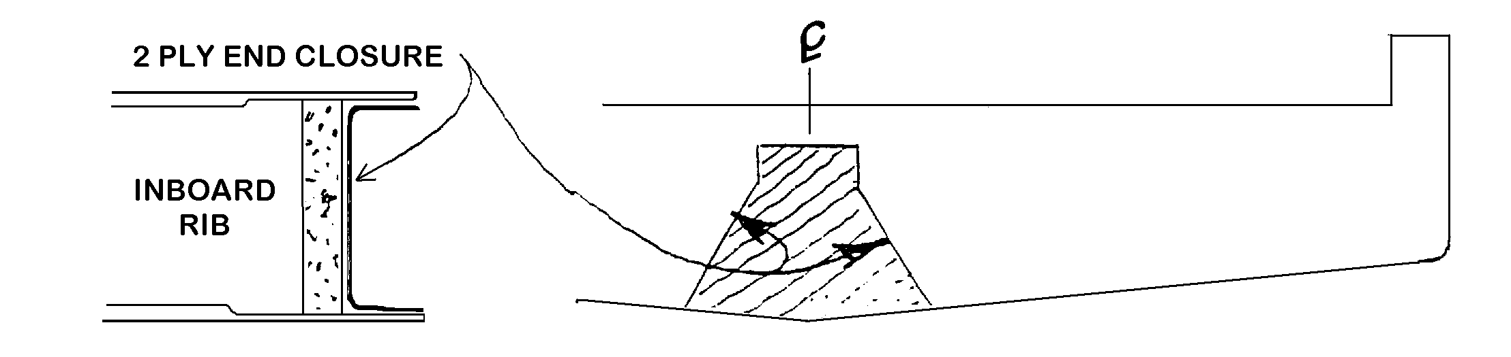
Once again install the elevator horn first making a ¾ inch relief slot in the bottom skin. Install all 8 bolts to assure clean fit.

Recess the hinge areas by 3/32 inch as you did on the stabilizer. The areas relieved are between BL 4 to BL12 and between BL29.5 to BL37.5 left and right. Overlay the stabilizer and assure that the cut-outs are aligned.

Cut out the trim tab with a fine saw blade. Use a sanding block to straighten the edges. Face the spar edges with two ply of BID after preparing all the corners of edges for micro-flox joints. Use a high speed Dremel router to open a slot in the bottom skin and foam where shown for the small horn. Flox the horn into place. Cut two 3 inch sections of MS 20257P1 (¾ inch) hinge. Shorten the pins and crush the extrusion slightly to trap the pins. Pop rivet these hinge sections to the tab and elevator with 3/8 inch spanwise spacing. Test the tab to assure it moves freely.

HINGING THE ELEVATOR

It is time to hinge the elevator. When making hinges for the elevator make all the control surface hinges for the aircraft. Fourteen are required.

Take the pieces of MS 2000 IPS (1¾ inch wide) aluminum hinge strip and saw 14 pieces 8 inch long. A hack saw or band saw will do the job. Clean up the hinges with a file or sanding table disc. The hinge pins must now be trapped so they cannot fall out due to vibration. This can be accomplished by removing the pins, cutting them about ¼ inch short, replacing them, and mashing the end of the extrusions.

You need to drill the hinges as shown.
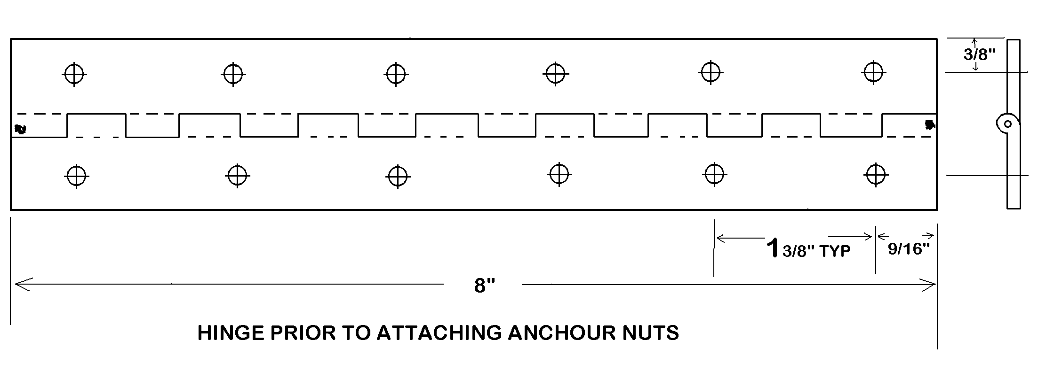
Make a precise drill jig from a scrap piece of aluminum or steel angle that has one leg about 1 inch wide. This guide will be used to make all 12 hinges on the aircraft so locate and drill the holes very accurately so that hinges are interchangeable and reversible.
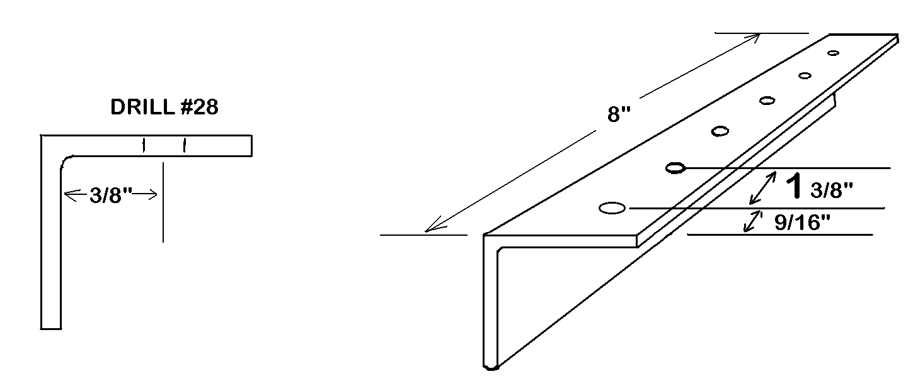
Use the angle bracket drill jig to locate and pilot drill the 12 holes in each hinge.
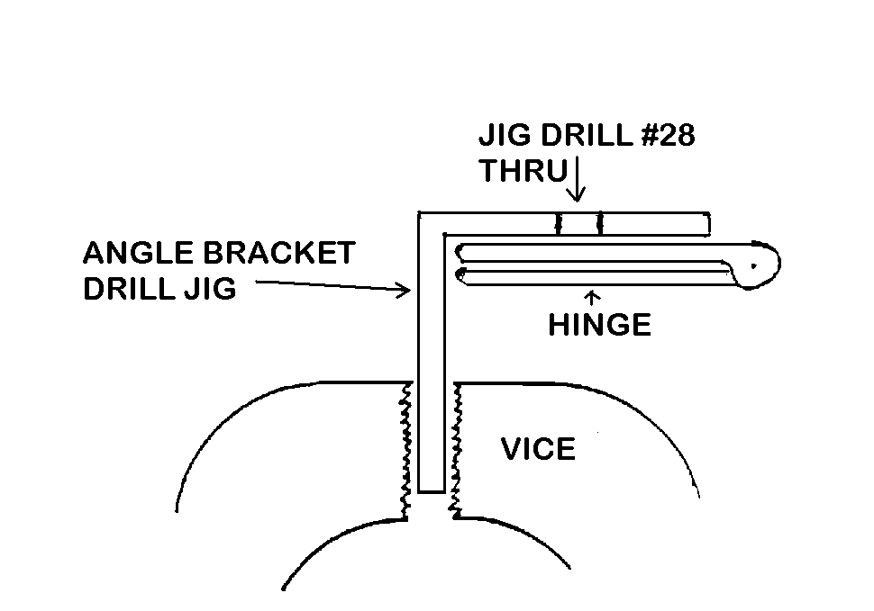
Accomplish this by clamping the angle in a vise. Close the hinge but space it slightly with some tape or thin cardboard. Clamp it in the closed or folded condition in the drill guide with one or two “C” clamps. Pilot drill the holes (two at a time) with a #28 drill bit. Drill all 14 hinges.

The hinges require anchor nuts down just one line of holes. Be sure to install the 6 nuts on the bottom as shown in the sketch. Use either a commercial drill jig (or a K1000-08 anchor nut in lieu of a jig) to locate and drill the 3/32 holes for the rivets which retain the anchor nuts.
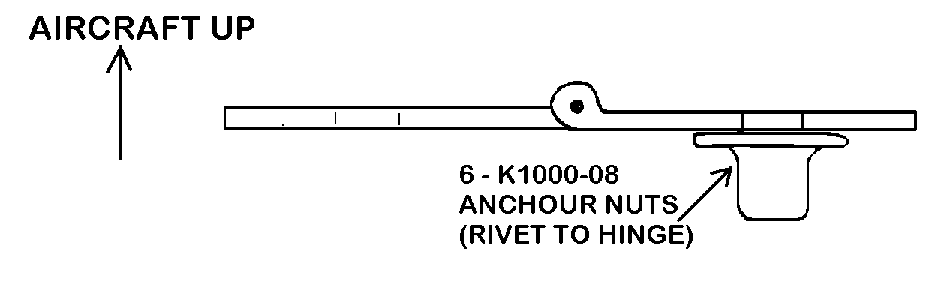
The next step is to install the four hinges in their proper positions on the top stabilizer skin. The anchor nut part of the hinge will go towards the elevator when actually installed. Place the hinges on the trailing edge of the upper skin with their pins centered over the recessed edge. Mark their hole locations. Check with a long straight edge to assure that all the hole marks fall on a straight line. If they do not the elevator will not hinge properly and the problem must be corrected.

Drill #28 pilot holes for the hinge mount screws. Open these with a #19 drill and countersink with a 100 degree countersink. Countersink just deep enough that the AN M524694-55 mount screws sit properly with the A3135-017-24A Tinnerman washers. With the screws and Tinnermans in place secure the hinges to the stabilizer with AN364-832A thin elastic stop nuts over AN960-8 washers.
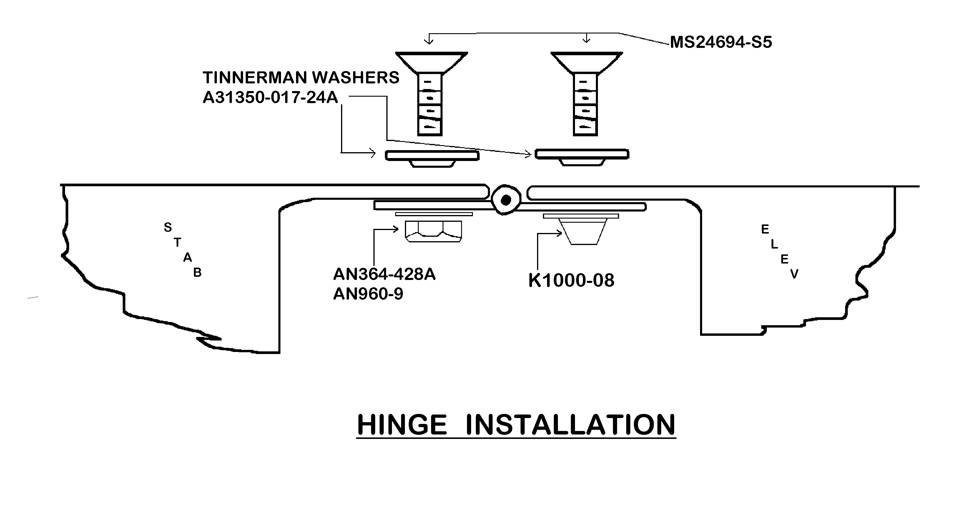
Now place the stabilizer and elevator right side up on the bench. Determine where the hinge mount holes should go in the elevator so that the hinge gap between the two surfaces is minimal. A 1/16-inch clearance is acceptable. Proceed and mount the hinges to the elevator.

The elevator must be able to travel at least 20 degrees down. It will probably be necessary to relieve the stabilizer lower hinge channel lip where the elevator horn strikes it. Do not remove material forward of the vertical web as this will make the stabilizer structurally unsound.

This is the time to close the forward end of the elevator balances. First remove any excess skin that prohibits proper movement of the elevator. Make two end pieces of ½ inch thick foam (Laminate 2 pieces of ¼ to get the ½ thickness.) Bond the ½ foam to the front end of each balance with 5-minute epoxy. Shape the foam removing some glass skin for corner radius. And allow plenty of clearance where the elevator balance swings past the stabilizer.

Take a sharp knife and remove foam for flox joints all around the forward ends. These flox joints must be strong because they will structurally secure the front-end closures and thereby retain the mass balance weight. If they were to come loose in flight they could jam the controls. Add the flox and cover the ends with three layers of BID. Trim when “green

You are now ready to mass balance the elevators. Make ¾ inch diameter holes in the exposed faces of the outboard ribs. The holes should be about 2 inches back from the leading edge of the balance but forward of the little bulkheads. The weight will be poured through these holes.
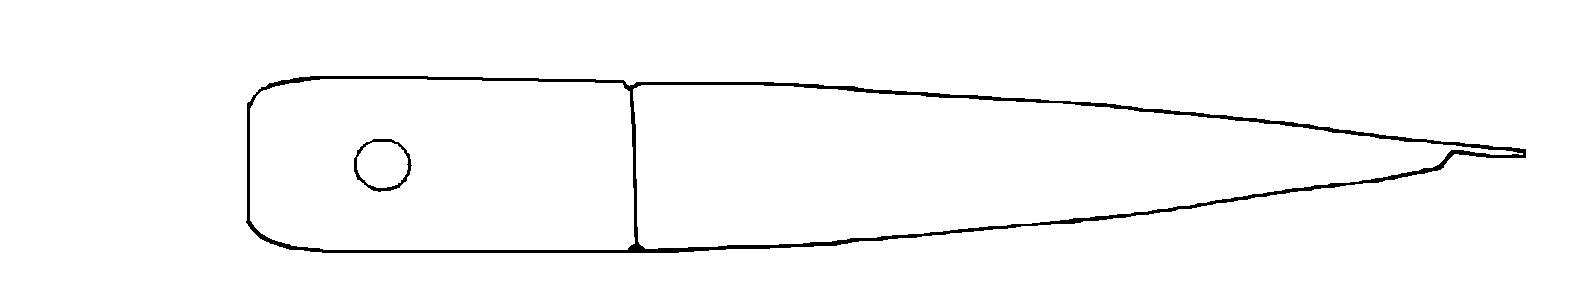
Place the stabilizer flat on the edge of a bench and weight it down. The elevator should hang down about 20 degrees under its own weight. Tape a cup on one or both balances. Fill the cups with lead shot until the elevator surface balances. You will be adding resin so about 10% of the shot may be removed.
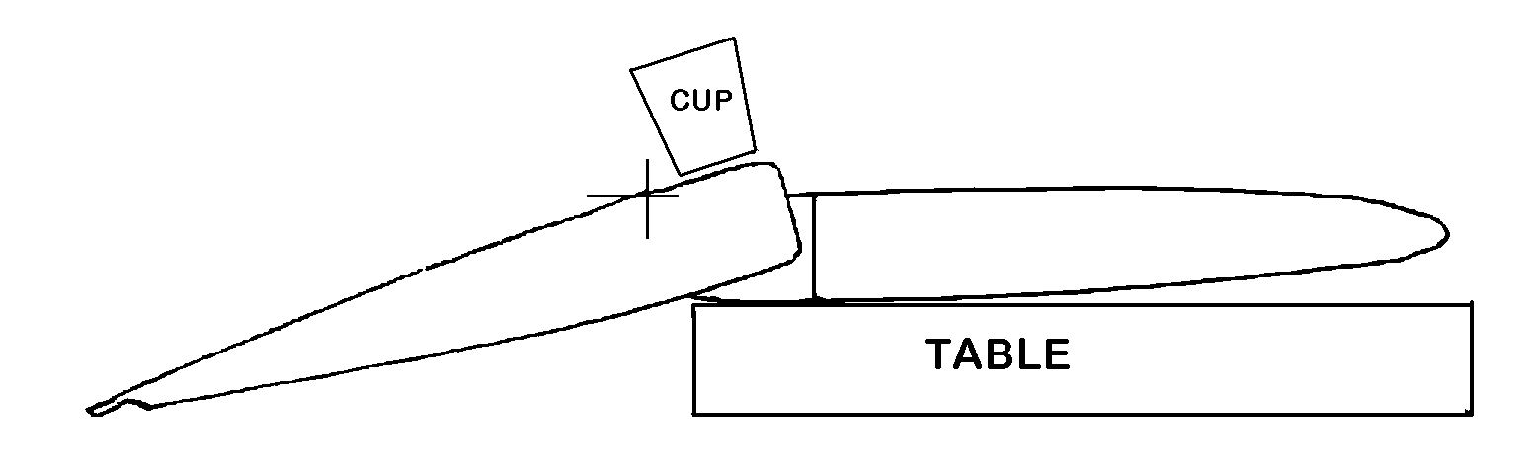
Mix the shot with some resin. Stir just a little flox into the mixture that results. Pour the mixture equally distributed into the left and right balance areas using the rib holes. Seal the rib holes with tape. Prop the horizontal tail so that the balances are down and the resined weight will cure in the very forward end of the balance structures.
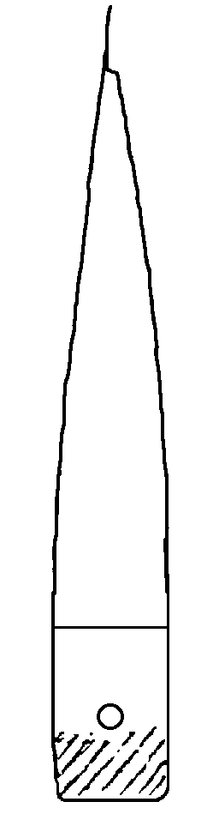
After the weight cures in place check again for balance. The elevator should be a little overbalanced to allow for paint. If the overbalance is extreme, excess weight may be drill out after painting. If the balance is light, add additional shot, resin and flox.

Remove the screws that hold the hinges to the stabilizer. Remove the elevator. Remove the eight bolts that hold the horn. Clearly mark the center line. Using a hack saw or band saw cut through the center line creating separate left and right elevator pieces.

Construction of the horizontal tail assembly is complete.
OPTIONAL ELECTRIC TRIM

Some builders may elect to install an electrical pitch trim in lieu of the mechanical boden cable supplied with the kit. After market suppliers provide excellent electrical driven servos for this purpose. The installation modifications should be made prior to installing the bottom skin of the elevator. Be sure to plan ahead for the entire installation; think ahead regarding details of the required wiring and its routing.

Start by boxing off an appropriate area in the elevator using Clark foam ribs positioned about 2 inches and about 5.5 inches respectively outboard of the inner rib. The servo will be mounted securely in that box. See next page.

Drill 4 holes through the skin for counter sunk attach bolts (about #8). These holes must be reinforced prior to countersinking. Using a Dremel tool and burr, enlarge the hole in the inner surface skin layer and foam core to about ½ inch diameter. Undercut the foam a little to prevent the reinforcement from falling out. Fill with micro/flox. Re-drill the 4 holes and countersink the outside skin side for the bolts. Use elastic stop nuts to secure the servo.

After mounting the servo, flox an elevator trim horn in proper position for alignment. Don’t use the position shown for mechanical trim. The push rod is normally supplied with the trim servo. Otherwise make one. Be sure that this link is strong and that the servo cannot come loose; elevator flutter may occur.

Modify the bottom skin with a servo access door. Keep this cut-out small with radiused corners because the elevator skin carries structural stresses. See the wing section for hints on how to make a good door.
